**Differences in Sex on Weight Change’s Effect on Cholesterol**

2/8/2024, Kath Fillman

**Introduction.**  A four year randomized clinical trial focused on the efficacy of nonpharmacologic approaches for the treatment of stage 1 hypertension that used a lifestyle intervention program and drug therapy to gather data on the effects of weight loss on participant's indicators of health, including cholesterol levels. This analysis aimed to ascertain the effect of weight change on cholesterol change with and without adjusting for sex as well as if sex is a confounding factor in this relationship.

**Dataset.** The dataset tomhs.csv was provided by the instructor. It contained data from 902 participants(234 placebo, 668 treatment) in 126 categories including the clinic they were treated at, study group, age at beginning of study, sex, race, smoking status, weight, blood pressure, total cholesterol, and blood glucose. Variables of interest (change in weight and cholesterol) were calculated by subtracting the subject’s baseline measurements (wtbl/cholbl) from their measurements at the 1 year mark (wt12/chol12).

**Exploratory Data Analysis.** Change in weight had a mean of -10.52 lbs with a standard deviation of 9.4 (table 1). The distribution of measurements is approximately normal with a slight left skew (fig 1). When grouped by sex, men had a mean change in weight of -12.03 lbs and a standard deviation of 9.65; women had a mean total weight change of -8.15 lbs with a standard deviation of 8.49 (table 1). Change in cholesterol had a mean of -7.22 mg/dL with a standard deviation of 25.85 (table 1). The distribution of measurements is approximately normal with a slight left skew (fig 2). When grouped by sex, change in cholesterol in men had a mean of -9.07 mg/dL with a standard deviation of 23.3; women had a mean change in cholesterol of -4.31 mg/dL with a standard deviation of 29.2 (table 1). The relationship between change in weight and change in cholesterol seems to be approximately linear (fig. 3). Figure 4 shows the relationship between both weight change and cholesterol change grouped by sex.

**Methods.** The association between change in weight and change in height while controlling for sex was investigated using multiple linear regression. The association was summarized using the slope of the line. Both an unadjusted model and a model adjusted for sex were considered. P-values less than 0.05 were significant. All analyses were performed in R-studio version 2023.12.1, build 402.

**Results.** The results of the multiple linear regression analyses, both unadjusted and adjusted for sex, are shown in table 3. The unadjusted slope is 0.5456 and the adjusted slope is slightly less steep at 0.5169; both slopes are statistically significant (p<0.0001) (table 3). The adjusted R2 value for the unadjusted model is 0.0392 and slightly higher at 0.0419 for the adjusted model. A standardized residual plot (fig. 5) shows a relatively linear relationship between the variables and no large residual values. To further confirm there were no influential points, Cook’s distance was plotted (fig. 6); no influential points were found.

**Conclusions.**

The relationship between total cholesterol change and total weight change has a slope of 0.5456; when adjusting for sex the slope is 0.5169 (table 3). In this study, sex is not a confounding factor in this relationship; there is little difference in the total weight change variable when adjusted for sex.

**Appendix.**

**Table 1. Summary Statistics**

|  | | **Sex** | | **Total** |
| --- | --- | --- | --- | --- |
| **Male** | **Female** |
| **Change in Weight** | **Mean** | -12.03 | -8.15 | -10.52 |
| **SD** | 9.65 | 8.49 | 9.4 |
| **Change in Cholesterol** | **Mean** | -9.07 | -4.31 | -7.22 |
| **SD** | 23.3 | 29.2 | 25.85 |

**Table 2. Proportions of Sex**

|  | **N** | **Proportion** |
| --- | --- | --- |
| **Male** | 557 | 0.6175166 |
| **Female** | 345 | 0.3824834 |

**Table 3. Model Summary**

| **Unadjusted Model** | | | | | |
| --- | --- | --- | --- | --- | --- |
|  | **Slope** | **Intercept** | **95% CI** | **p-value** | **Adjusted R2** |
|  | 0.5456 | -1.4402 | 0.3631, 0.7280 | <0.0001 | 0.0392 |
| **Adjusted Model** | | | | | |
|  | **Slope** | **Intercept** | **95% CI** | **p-value** | **Adjusted R2** |
| **Males** | 0.5169 | -2.8319 | -5.9597, 0.2959 | <0.0001 | 0.0419 |
| **Females** | 2.7949 | -0.7874, 6.3772 | 0.1266 |

**Figure 1.**

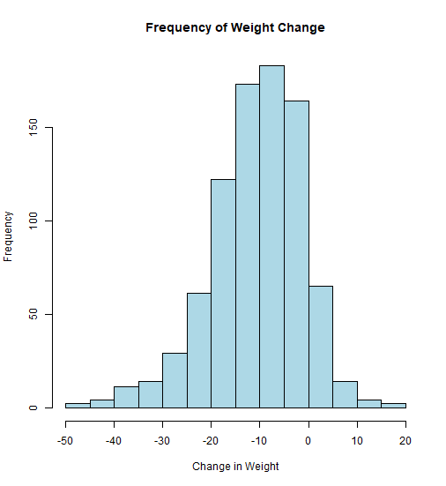

**Figure 2.**

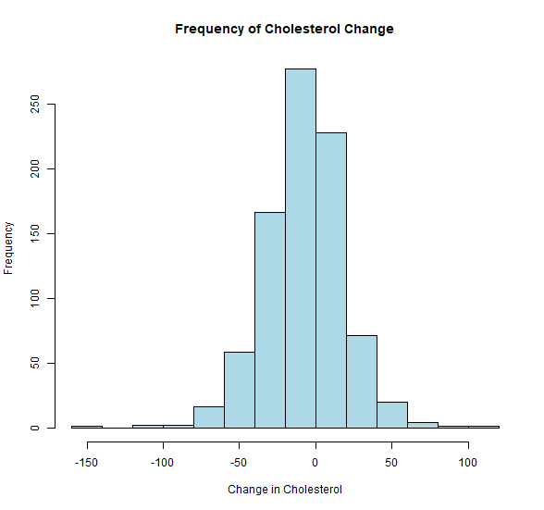

**Figure 3.**

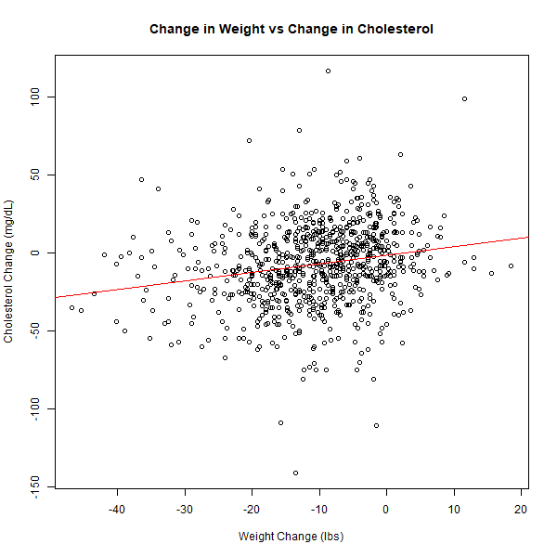

**Figure 4.**

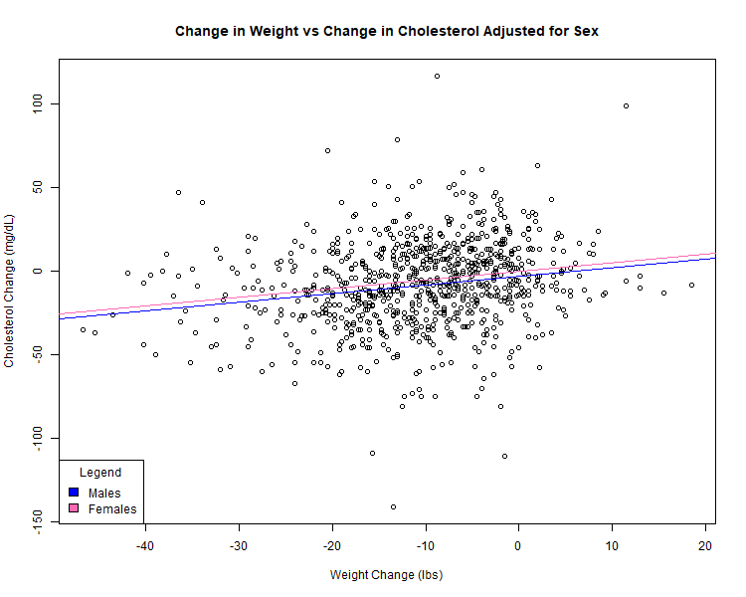

**Figure 5.**

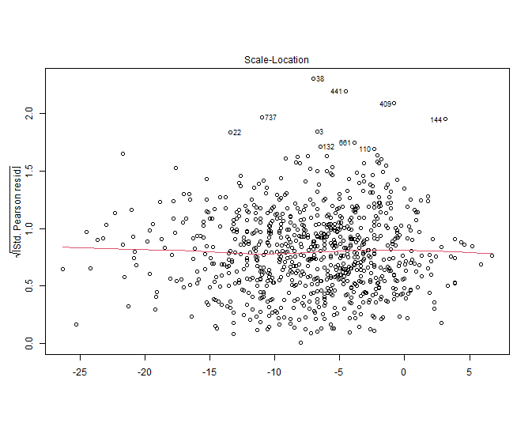

**figure 6.**

